export default function PersonalWebsite() {
return (

{/* Hero Section */}

Fikameni Haindongo

Mechanical Engineering Student • Entrepreneur • Future Petroleum Engineer

About Me

Contact

{/* About Section */}

About Me

Hi, I’m Fika — a passionate Mechanical Engineering student from Namibia with big dreams in technology, business, and petroleum engineering. I enjoy learning new skills, building creative ideas, and inspiring young people to aim higher.

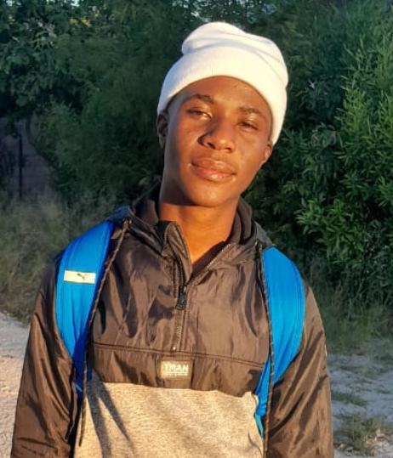
I’m also building my own fragrance brand called Mweshipange's Fragrance, while exploring opportunities in engineering, leadership, and innovation.

{/* Skills Section */}

Skills & Interests

{[
"Engineering",
"Entrepreneurship",
"Leadership",
"Public Speaking",
"Business Ideas",
"Technology",
"Design",
"Problem Solving",
].map((skill) => (

{skill}

))}

{/* Quote Section */}

“Jealousy is national but success is personal.”

{/* Contact Section */}

Get In Touch

Interested in collaborating, networking, or supporting my journey? Feel free to reach out.

📧 Haindongofikameni@gmail.com

📱 +264 81 402 0777

📍 Namibia

{/* Footer */}

© 2026 Fikameni Haindongo. All rights reserved.

);
}
Your email address and phone number have been added to the website’s contact section.

